SUMMERFEST T-SHIRT ORDER FORM

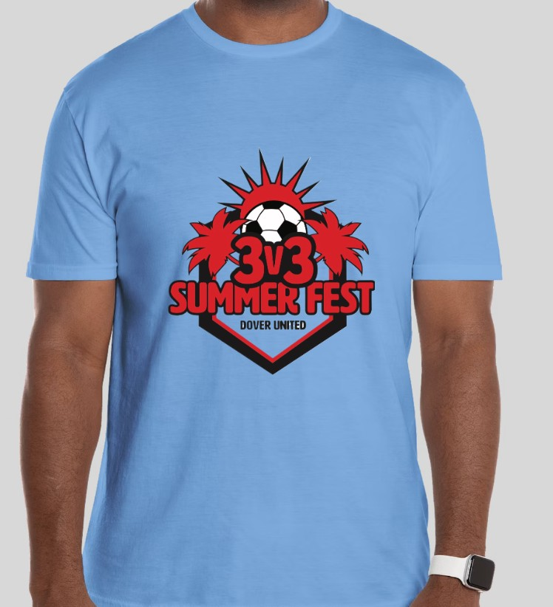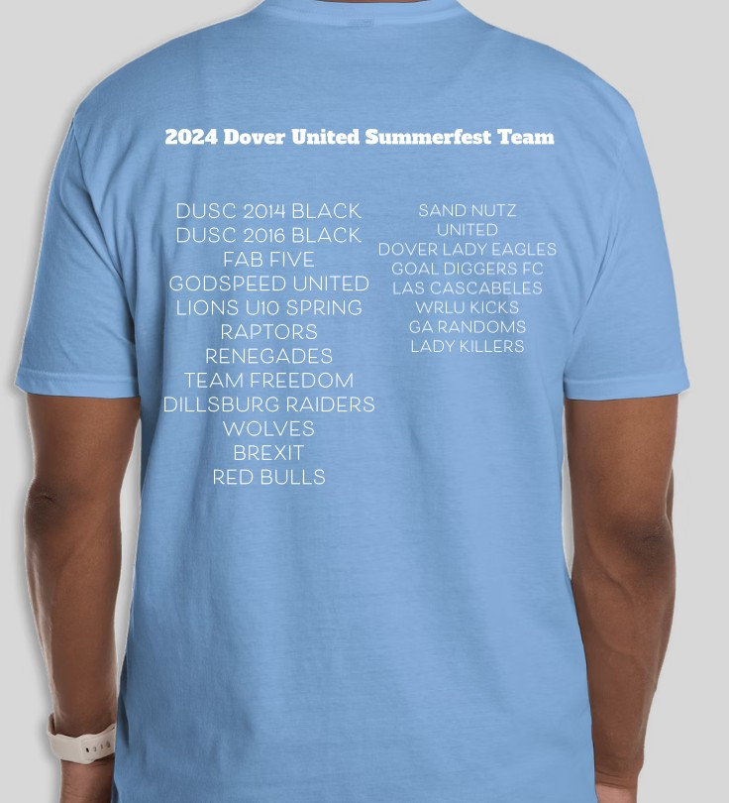
(Order for the entire Team on this form)

T-shirt size Qty. ordered Cost per shirt Total cost

Youth Medium |  | x $20.00 | =
Youth Large |  | x $20.00 | =
Adult Small |  | x $20.00 | =
Adult Medium |  | x $20.00 | =
Adult Large |  | x $20.00 | =
Adult X-Large |  | x $20.00 | =
Adult XX-Large |  | x $23.00 | =
Total Qty. ordered: |  | Total cost: | =

Team Name:

Age Group: (circle one) U9/10 U11/12 U13/14 High School Gender: (circle one) Male / Female

Contact Person: Cell Phone:

(Please DO NOT write below DUSC officials only)

Check # Date Received: Order Ref #

Please send this form and send only one check payable to: DUSC
Send to:

Summerfest T-shirts c/o Mel James 1884 Ashcombe Dr
Dover, PA 17315

